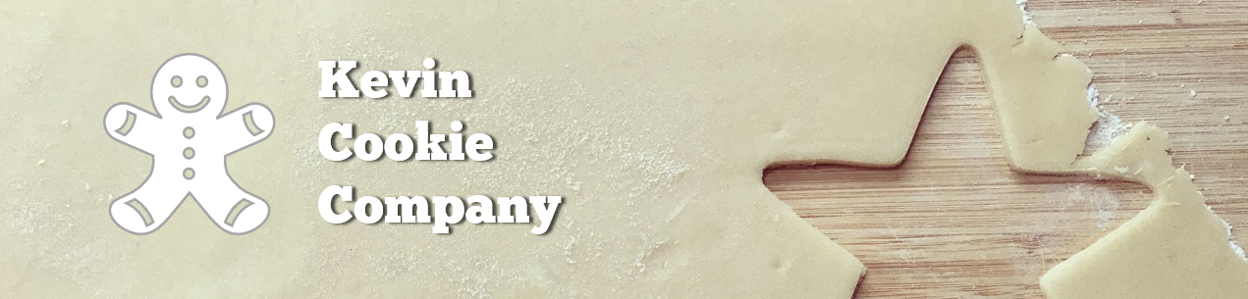

Cookie Order Form

|  |  |  |
| --- | --- | --- |
| Order Number: | 548625 | |
| Your Full Name: | Jennifer Biggs | |
| Cookie Type & Quantity: | Chocolate Chip | 20 |
| How did you hear about us? | Tutorial videos on YouTube | |
| Preferred Delivery Method: | Hand delivered | |
| Desired Delivery Date: | 2/14/2021 | |

We appreciate your business!